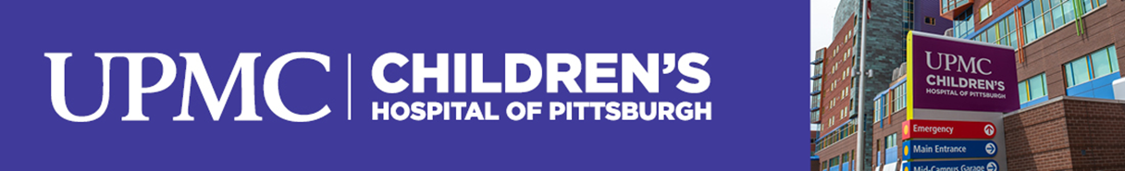

Summer Research Internship Program 2024
Settled in the hillside community of Lawrenceville, John G. Rangos Sr. Research Center serves as the hub of pediatric research, in Pittsburgh, and is one of the fastest growing pediatric research programs in the United States. Through the collaboration of UPMC Children’s Hospital of Pittsburgh and the University of Pittsburgh School of Medicine, pediatric researchers are advancing immunosuppressant management to wean transplant patients from anti-rejection drugs, seeking a cure for juvenile diabetes, and expanding the research frontier with new and innovative therapies for the cure of childhood disease and disability.

Under the direction of Drs. Sunder Sims-Lucas and Michelle Manni, the Children’s Hospital of Pittsburgh, Rangos Research Center offers an eight-week, paid summer internship program designed for undergraduate students, from any college or university. Participants will learn design strategies & methods, the rationale, and many other aspects of biomedical research. Students will engage in studies, related to pediatric research, under the direct supervision of experienced researchers, in the areas Adolescent & General Pediatrics, Allergy & Immunology, Cancer & Blood Disorders, Cardiology, Endocrinology, Diabetes & Metabolism, Genetics and Developmental Biology, Hematology & Oncology, Infectious Diseases, Medical Genetics, Nephrology and Neurobiology.

The program will commence the first week of June and conclude the last week of July. Participants are expected to complete the full 8-week program, which includes working 40 hours per week, to receive compensation at $15/hr. (no overtime is allowed). At the end of the program, participants are required to present their studied research through the Poster Day forum. Housing may be provided with this program.

Internship Program Eligibility:
The applicant must:
- Be actively enrolled in a degree-granting program with an institution of higher learning. Science based programs are preferred.
- Be able to verify:
  - undergraduate coursework of two semesters of education, or
  - coursework of at least one semester of education remaining upon completion of the internship, or
  - acceptance into an advanced degree program upon completion of the internship.
- Provide proof of:
  - Cumulative GPA of 3.0 or higher.
  - U.S. Citizenship or Legal Status.
- Successful submit the SRIP Written Evaluation and Application
- Complete All Onboarding Paperwork which includes:
  - Required Clearances (Act 33, Act 34, and Act 73)
  - Pre-employment Health Assessment (self-scheduled and required to be up to date on immunizations and free from contagious disease)
  - I-9 Form
The Application will be available at www.chp.edu, until December 31, 2023.
Contingently accepted participants will be notified, in February 2024, to begin the onboarding process. To receive an Acceptance Letter and Mentor Assignment, participants must complete all aspects of onboarding.
For additional information, please contact the Directors or Research Administration.

Sunder Sims-Lucas, PhD
Associate Professor of Pediatrics
Division of Pediatric Nephrology
Rangos Research Center 5th Fl.
412-692-7927 sunder.sims-lucas@chp.edu

Michelle Manni, PhD
Assistant Professor of Pharmacology and Chemical Biology
Thomas E. Starzl Biomedical Science Tower
412-648-1381 mlm45@pitt.edu

Research Administration
UPMC Children’s Hospital of Pittsburgh
Rangos Research Center 3rd Fl.
412-692-6081 chpsrip@upmc.edu

