UPMC Children’s Hospital of Pittsburgh Clinical Faculty
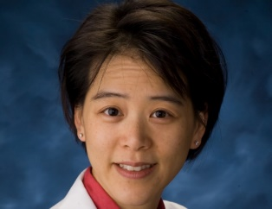
Philana “Ling” Lin, MD, MSc
Associate Professor
Director, Division of Infectious Diseases
Director, Pediatric Infectious Diseases Fellowship Program

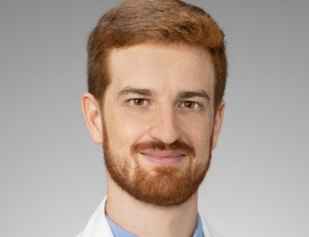
Jonathan Albert, MD
Assistant Professor
Associate Director, Pediatric Infectious Diseases Fellowship Program


Zachary Aldewereld, MD
Assistant Professor

Brian Campfield, MD
Assistant Professor



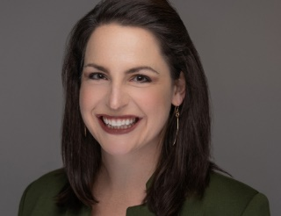
Megan Culler Freeman, MD, PhD
Assistant Professor


Michael Green, MD, MPH
Professor
Co-Director, Transplant Infectious Diseases Program
Medical Director, Antimicrobial Stewardship Program

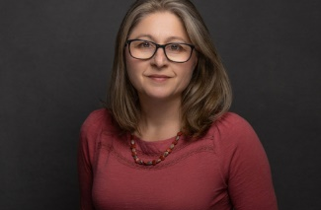
Anita McElroy, MD, PhD
Associate Professor

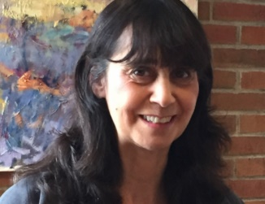
Marian Michaels, MD, MPH
Professor
Co-Director, Transplant Infectious Diseases Program
Medical Director, Pediatric HIV Center


Andrew Nowalk, MD, PhD
Associate Professor
Clinical Service Director
Co-Director, Pediatric Residency Program

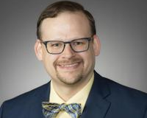
Glenn Rapsinski, MD, PhD
Assistant Professor
Director of Medical Student and Resident Education, Infectious Diseases

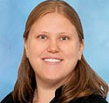
Terri Stillwell, MD
Assistant Professor
Medical Director, Infection Prevention Program

Coming Soon!
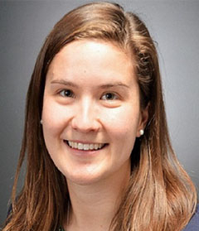
Catherine Hayes, MD
Assistant Professor
Medical Director, Antimicrobial Stewardship Program

